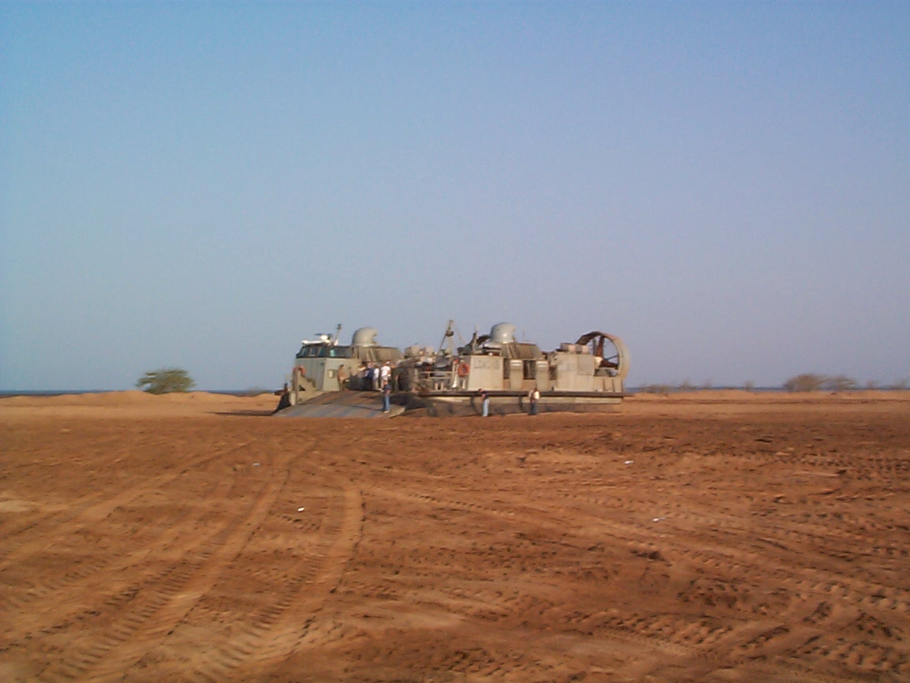
Soldiers of the 80th Transportation Detachment provide movement control support to all services. Here, a USMC air cushion landing craft is loaded with cargo brought in by USAF aircraft for transport to coalition naval vessels engaged in counter-terrorism operations.
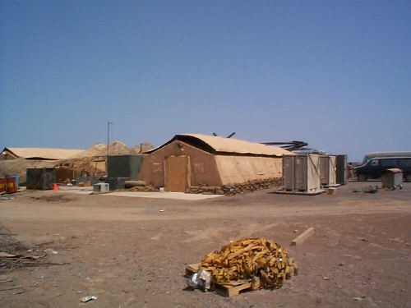
The 80th Transportation Detachment’s passenger terminal and living quarters

